1.
SELECT count(*) FROM [Customers] where Country = 'Germany'
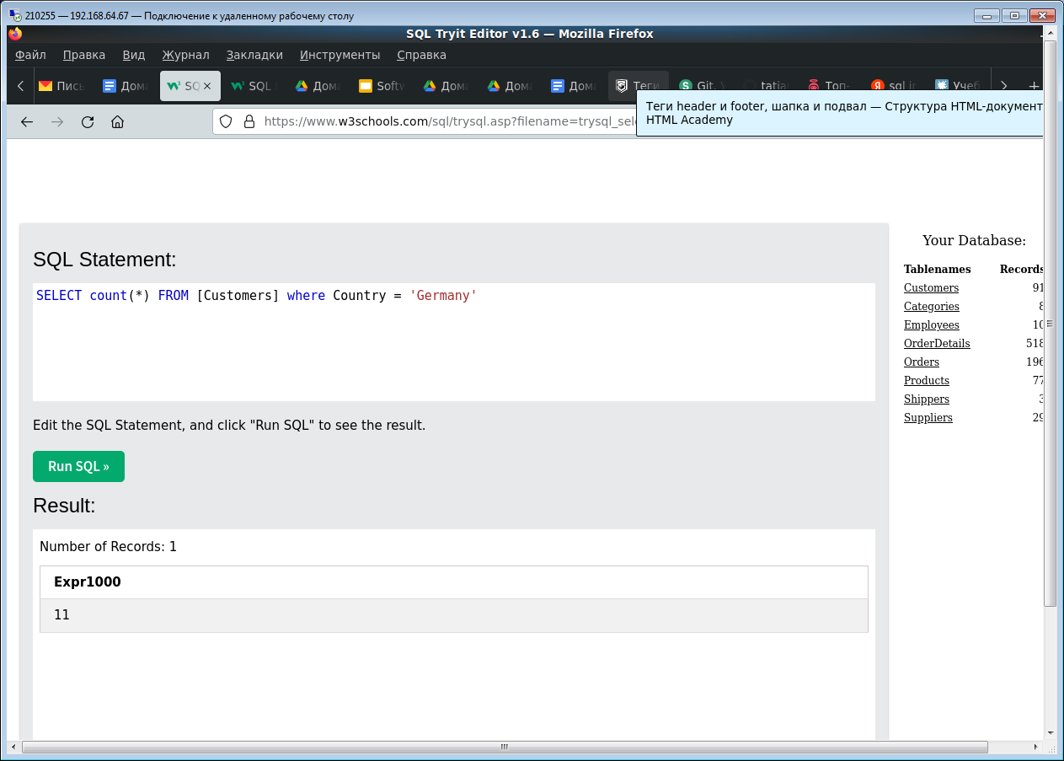

2.
SELECT * FROM Customers where CustomerName like '%e'
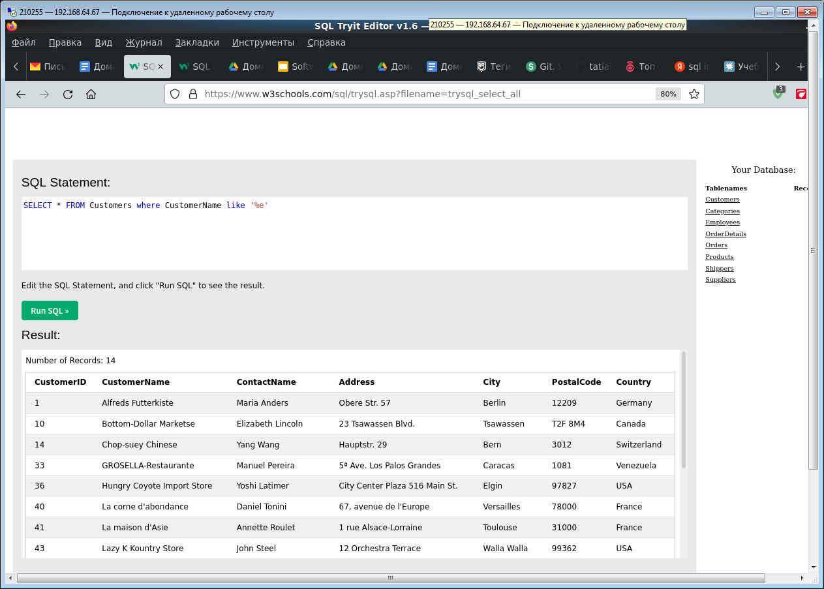

3.
Insert into Customers (CustomerName) values ('Shushakova')
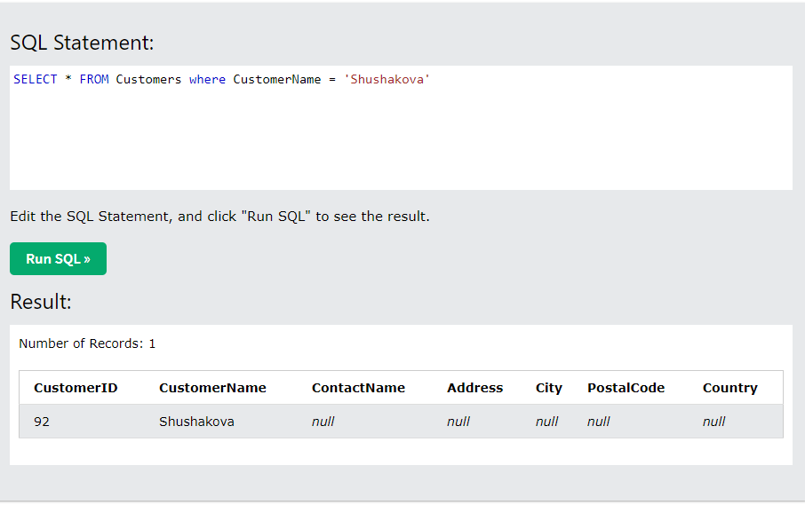

4.
Update Customers Set CustomerName = ‘Tatiana Shushakova’ where CustomerID = ‘92’
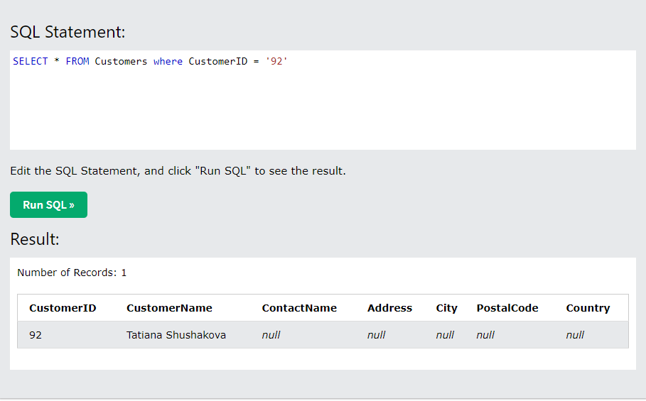
5.
Delete FROM Customers where City = 'Nantes'
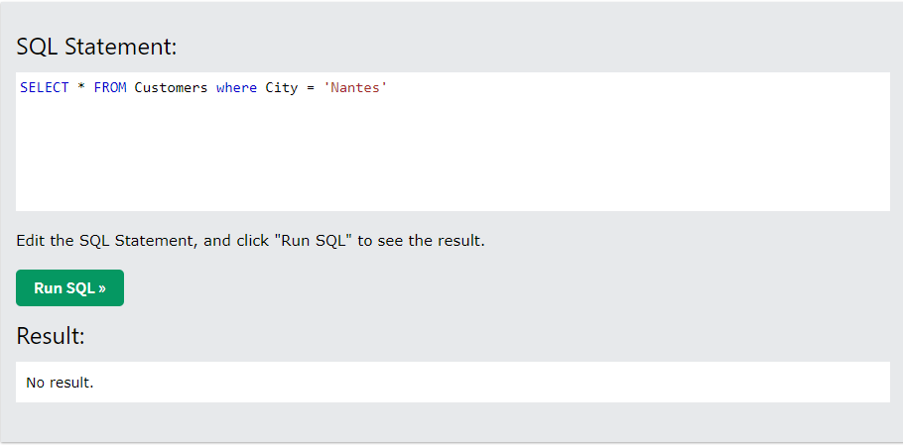

6.
SELECT Orders.orderID, Employees.FirstName FROM Orders
inner join
(SELECT * FROM Employees where FirstName = 'Steven'
) Employees
on Orders.EmployeeID = Employees.EmployeeID
